
College of Engineering and Physical Sciences
School of Informatics & Digital Engineering, Computer Science
Final Report or Term Report
Title: add a few words that informs the reader of something important
Author
E-mail: 230093849@aston.ac.uk
Supervisor: Dr Aniko Ekart
April 2026
Abstract
Write 150-200 words that resumes what you did. It should have a single paragraph detailing objective, methods, results, and conclusions without references/citations. The title has captured the attention of your reader, now the abstract will be responsible for making the reader wanting to read your work. So it should describe all that you did in those few words: problem, solution, results, and perspectives. Methods should inform the reader about how you performed the study, detailing the steps you took and the methodological choices of your design, so others may follow your steps and either reproduce, replicate, or repeat your results.

Alternatively, you could use this format (also between 150-200 words):
Objective: Lorem ipsum dolor sit amet, consectetur adipiscing elit, sed do eiusmod tempor incididunt ut labore et dolore magna aliqua.
Methods: Ut enim ad minim veniam, quis nostrud exercitation ullamco laboris nisi ut aliquip ex ea commodo consequat.
Results: Duis aute irure dolor in reprehenderit in voluptate velit esse cillum dolore eu fugiat nulla pariatur.
Conclusions: Excepteur sint occaecat cupidatat non proident, sunt in culpa qui officia deserunt mollit anim id est laborum.

Keywords: topic1, topic2, topic3, topic4, topic5.

List of Acronyms
TCP/IP Transfer Control Protocol/Internet Protocol
RAM Random Access Memory

Dedication | Acknowledgements | Preface (each optional – choose one)
I dedicate this work.

(remove this if Acknowledgements or Preface)
List your acknowledgements here (except for partial Term Reporting – save it for the final version).
Create single pages for each type you want to add (either dedication, acknowledgements, or preface).

Table of Contents
1 Introduction 7
1.1 Motivation 8
1.2 Organisation 8
2 Related work 9
2.1 Bias In Machine Learning 9
2.2 Fiarness Metrics 9
2.3 Bias Mitigation Techniques 10
2.4 Existing Bias Detection Tools 11
2.5 Research Gap 12
3 Methodology and Design 14
3.1 Project Management Methodology 14
4 Results 24
4.1 Heading 2 30
4.1.1 Heading 3 31
5 Conclusion (or Final considerations) 32
5.1 Future work 32
References 33
6 Appendices 34
6.1 Appendix 1: SDLC details 34
6.2 Appendix 2: Code 34
6.3 Appendix 3: Meetings with supervisor 34

(after updating the table of contents, re-apply Style “Table of Contents – items”) – remove this
List of Figures
Figure 1: A panda sleeping. This is called the ‘caption’ of a figure. Error! Bookmark not defined.

Introduction

Decisions such as job application rejections, reoffending risk assessments and bank loan denials often appear definitive and impartial, however it is frequently unclear wheather the process was fair or if a machine learning algorithm affected these results. Artificial systems are increasingly used in areas with elevated risks such as recruiting, healthcare, credit scoring and criminal justice which significantly impact individuals’ lives. Although the systems used are considered neutral and reliable, their performance is dependent on the data used for training. Historical data is commonly used to train data, which often reflects social inequalities; as a result, machine learning models can imitate and reinforce these biased patterns and result in unfair outcomes for specific demographic groups.

This issue has legitimate real-world consequences that affect society at both the individual and organisational levels. For example, Amazon's internal recruitment tool was found to disadvantage female candidates by imitating male-dominated hiring patterns, which was discontinued after this bias was detected (Dastin, 2018). Additionally, the COMPAS recidivism tool applied in the criminal justice system in the United States, was found to produce nearly twice as many false positive rates for Black defendants as it did for white defendants (Angwin et al. 2016), clearly highlighting the racial bias within credible systems which may have lasting impacts on individuals’ lives. Both the mentioned cases demonstrate the persistent risk of bias in artificial intelligence in machine learning systems trained on existing social disparities.

Although tools to detect and correct algorithmic bias are available, their use in everyday life is very limited. To assess differences across demographic groups, researchers have developed fairness metrics such as demographic parity, equal opportunity and equalised odds. Frameworks such as IBM’s AI Fairness 360 provide strong detection and mitigation abilities (Bellamy et al., 2019), however these tools rely on programming skills and an understanding on maching learning pipelines, which non-technical users lack. As a result, HR experts responsible for hiring applications or bank managers determining loan acceptances, are unable to assess fairness using these technical tools. This leads to fairness evaluations that are typically insufficient or overlooked, even when advanced techniques are available. Ferrara et al. discovered in a survey of 117 industry professionals, that fairness is often ignored through system development, compared to accuracy and security which are prioritised (Ferrara et al. 2023). This is usually due to the significant gap between technical ability and practical application, rather than a lack of organisational concern.

This project addresses the gap mentioned, by delivering a web-based bias detection tool accessible for non-technical users. It allows users to upload a CSV dataset or select a popular sets already available, then the user can select the outcome and sensitive attribute of interest. The tool internally trains a decision tree classifier, generates predictions and analyses fairness metrics, displaying the findings simply and clearly with visualisations. The tool also includes a comparison of before and after mitigation techniques are applied, demonstrating the changes in fairness when reweighing is used, making the trade-offs between fairness and performance clear. The evaluation uses three real-world datasets: UCI Adult Income, COMPAS Recidivism, German Credit, and Heart Disease. The EU AI Act (2024) requires bias auditing for highly risky systems in credit scoring, recruitment and criminal justice, which consequently makes easily accessible fairness tools a legal requirement.

Motivation
Studying computer science involves not only the development of systems, but also a detailed evaluation of their weaknesses. For example, a hiring tool that denies qualified applicants does not leave a documented explanation for their rejection, and a credit scoring model that unfairly rejects applications does not reveal its discriminatory behaviour. Unfortunately, this harm tends to remain unnoticed by both affected individuals and organisations involved. This project is based on the idea that revealing bias within systems is key to correcting them for the future. Rather than creating new fairness metrics or algorithms, the project uses current fairness techniques and focuses on enhancing their usability for professionals who use AI systems in real-world settings, regardless of their technical abilities.

Organisation
The remaining sections of this report are structured as follows. Section 2 reviews related research on algorithmic bias, fairness metrics, and current tools while outlining key findings which influenced design decisions for this project. Section 3 discusses the design of the tool and performance, detailing its architecture, model selection and dataset choices. Section 4 displays and analyses the evaluation findings from all datasets, and finally, Section 5 summarises the results, limitations and recommendations for future research. !!!!!!!!!!!!!!!

Related work
This section reviews the literature, which was used in the design and development of this project’s bias detection tool. Key research findings are discussed, as they influenced decisions such as the datasets selected, fairness metrics and the prioritisation of usability.

Bias In Machine Learning
Algorithmic bias is an issue which can appear at any stage of the machine learning process, which is why continuous prevention techniques should be applied as early as possible. According to research, bias can be caused by historical bias in training data, sampling bias from unrepresentative datasets or bias introduced during optimisation processes (Mehrabi et al., 2021). Some researchers argue that bias actually emerges during initial stages, including data collection, feature selection, and model implementation, instead of a particular point. Considering this concept, this project measures the fairness of the model's results across demographic groups, rather than focusing on bias at a single stage.
Proxy variables present challenging obstacles in algorithmic fairness. The removal of sensitive attributes such as race, gender or age fails to prevent discrimination, due to related features still possibly storing this information and resulting in biased outcomes in models that appear fair (Barocas and Selbst, 2016). This impact is known as the disparate effect, which demonstrates that simply removing protected attributes does not eliminate the risk of bias. Therefore, the project's tool includes the sensitive attribute in its analysis, to ensure fairness is directly measured rather than assuming it by removing certain details.

Real-life examples highlight the negative impacts of algorithmic bias, as mentioned in cases in section 1. Both the Adult Income and COMPAS datasets were carefully selected to evaluate this project because their documented patterns are readily available in the literature. The tool’s findings will be compared against these established results to determine the effectiveness and accuracy of the tool.

Fiarness Metrics

The concept of fairness in machine learning varies according to its definition, as the fairness metrics selected impact how bias is identified and understood. This demonstrates how the selection of fairness metrics is a strategic decision with legal and organisational implications, not only technical (Pessach and Shmueli, 2022). Understanding these options influences the choice of metrics used for this project.

The tool uses three key fairness metrics, including Demographic parity, which measures if the model assigns positive predictions for different groups at the same rate. This measure was used due to its accessibility to non-technical users, and is also consistent with legal standards, such as the 80% rule in employment and credit regulation (Pessach and Shmueli, 2022). Another metric used was Equal opportunity, which involves testing whether the model finds individuals who get favourable outcomes equally across groups (Hardt et al., 2016). This is particularly important within hiring and loan approvals, as eligible individuals from minority groups are overlooked, creating serious long-term harm. Finally, Equalised odds were used to ensure that both the identification of eligible people and the distribution of model mistakes are balanced across groups (Hardt et al., 2016).

All three metrics are incorporated due to their mathematical incompatibility. It is usually impossible to meet all three criteria simultaneously when base rates between groups differ (Chouldechova, 2017). The COMPAS example demonstrates this issue, as the system achieved predictive parity across racial groups while violating equalised odds, resulting in nearly double the false positive rates for Black defendants as for white defendants (Angwin et al., 2016). This shows how model may meet one metric, yet still cause considerable harm, such as misleading stakeholders by reporting only one metric. Therefore, providing all three metrics offers a deeper and more accurate evaluation of the system’s fairness.

The literature reviewed reveals that selecting a fairness metric carries major legal and financial consequences, as different fairness constraints produce different costs. For example, in credit scoring, certain fairness standards affect profitability; it was found that independence-based constraints caused the greatest profit loss, compared to separation-based constraints aligned with equalised odds which offered the most sustainable balance (Kozodoi et al., 2022). This evidence reinforces the impact of fairness metric selections being both a technical and a business decision, with real-world consequences for organisations. This project provides a comparison of results before and after mitigation techniques are applied, illustrating these costs of metrics, to allow stakeholders to observe how reweighing affects each metric while evaluating the resulting drop in accuracy.

Bias Mitigation Techniques

After bias is detected, it is important to determine the most effective approach to address it. Researchers identify three main techniques for treating bias, including pre-processing, which makes changes to the training data before the model is developed. In-processing involves adding fairness standards during training, whereas post-processing modifies the model’s results after training is completed (Pessach and Shmueli, 2022). Each of the mentioned strategies has its own trade-offs, which should be considered before implementation.

!!!!!
Pre-processing was chosen for this project due to its compatibility with any classifiers and does not require access to the model’s underlying structure (Pessach and Shmueli, 2022). Specifically, a reweighing method will be used to adjust the influence of training data, by assigning sample weights to underrepresented groups, giving them greater influence without altering underlying datasets. This method was implemented using Scikit-learn’s ‘compute_sample_weight’ function where no external fairness libraries were needed. This ensures my project is accessible to non-technical users who may not have control over their model’s architecture and supports future versions of the tool, in which multiple model types can be used without altering the mitigation approach. Studies have confirmed the suggested trade-off, where reweighing DOUBLE CHECK PAPER IF THIS OR REWIGHING improves fairness metrics but slightly reduces accuracy (Bellamy et al., 2019). This trade-off is presented to users of the tool through a comparison of Model A and Model B, allowing them to assess both the improvement in accuracy and the associated accuracy cost.

In-processing techniques were not implemented since, unlike pre-processing, full access to the model’s architecture and training process is required, which is unavailable for black-box systems which display results without an explanation for how the decision was made internally (Pessach and Shmueli, 2022). Post-processing was also excluded due to its significant legal concerns (Bellamy et al., 2019), such as anti-discrimination laws, which may be broken when predictions are adjusted based on demographic groups.
Existing research reveals that no single technique can consistently deliver desired outcomes, as improving fairness within systems often sacrifices optimal accuracy or profit (Mehrabi et al., 2021; Kozodoi et al., 2022). Reweighing was selected due to its practical balance, compatibility with any model, ease of understanding, and, importantly, its transparency regarding its limitations, which is an essential aspect for tools intended for non-technical users. Bellamy et al. (2019) confirm that reweighing is one of the most well-established pre-processing mitigation techniques, having been implemented as a core feature of AIF360, which influenced its use within this tool.

Existing Bias Detection Tools
Due to the growing awareness of algorithmic bias, tools have been developed which allow organisations to identify and address unfair results within their own machine learning systems. For example, IBM’s AI Fairness 360 (AIF360) is a detection tool, which offers over seventy fairness metrics and bias analysis features throughout the machine learning process (Bellamy et al., 2019). This tool is one of the strongest and frequently used in academic research, along with this project, where it’s bias evaluation methods influenced several decisions including the implementation of reweighing to reduce bias and post-prediction fairness tests.

Tools such as Aequitas and Fairlean from the Microsoft tool kit, help audit model predictions across demographic groups. Similar to AIF360, they provide quantitative fairness metrics and technical documentation, allowing data scientists to identify differences and evaluate mitigation solutions. These tools help to translate fairness research into practise. However, these tools often assume users have advanced technical skills, which is rarely accurate. AIF360 and Aequitas require Python skills, along with familiarity with machine learning pipelines and statistical fairness, which can be an issue for users who control AI systems but are not specialised. A study of 117 industry professionals revealed that fairness is often disregarded during system development (Ferrara et al., 2023); this is likely due to the uneven distribution of required skills among teams. As a result, fairness checks are frequently neglected or assigned to a smaller group of technical experts.

This project addresses this gap by allowing advanced technology to be accessible to a wider population. Unlike AIF360 and similar systems, this tool does not require users to possess any programming experience or machine learning knowledge, making it accessible to all individuals. Users begin by uploading a dataset of their choice, or have the option to select an already available popular dataset, where they are able to specify columns for analysis and ultimately receive a clear fairness report shown as bar charts and simple, written English. This project does not intend to replace existing technical tools, but rather aim to make it more feasible for non-technical stakeholders to identify bias.

Research Gap

Research shows that despite the increasing availability of technical bias detection and mitigation tools, the development of tools that are accessible, user-friendly, and provide clear explanations remains limited. This matters because bias cannot be recognised at a particular moment; rather it can arise at different stages of the machine learning pipeline and cannot be represented by a single fairness metric (Mehrabi et al., 2021). Even when bias is identified, addressing it becomes an additional challenge organisations face, as reducing bias introduces unavoidable trade-offs between fairness and accuracy, which depend on the dataset or domain (Kozodoi et al., 2022). Although the tools designed to navigate this issue are technically advanced, they require expertise which most real-world decision-makers lack (Bellamy et al., 2019; Ferrara et al., 2023).

This project addresses the need for an extensive bias detection system usable by non-technical users by prioritising clarity and accessibility. Existing systems are quite complex, such as AIF360 and Aequitas, which require users to write code, configure machine learning pipelines and analyse statistical results on their own. This obstacle is not accidental, but rather due to these tools being developed by researchers for the use of other researchers (Bellamy et al., 2019). This is also challenging in an organisational aspect, as individuals responsible for implementing AI in crucial areas, such as HR managers and credit analysts, are often the least capable of evaluating the fairness of these systems, risking inaccurate, long-term decisions. Ferrara et al. (2023) identified this gap as a result of the lack of accessible tools rather than technical skills, as usability is not prioritised as much as technical issues within fairness research.

This project attempts to address prevalent gaps by presenting a tool that combines autonomous model training, simultaneous evaluation of three fairness metrics, clear results, and a final comparison of pre- and post-bias mitigation in the model. The tool is accessible through a web interface, which is designed considering users without prior programming experience, which is a feature most tools do not provide. Three real-world datasets were used to effectively evaluate the tool, including income prediction, criminal justice recidivism and healthcare; as previously mentioned, these sectors are especially vulnerable to biased algorithms.

Angwin, J., Larson, J., Mattu, S. and Kirchner, L. (2016) 'Machine Bias', ProPublica, 23 May. Available at: https://www.propublica.org/article/machine-bias-risk-assessments-in-criminal-sentencing (Accessed: April 2026).
Bellamy, R.K.E. et al. (2019) 'AI Fairness 360: An extensible toolkit for detecting and mitigating algorithmic bias', IBM Journal of Research and Development, 63(4/5), pp. 4:1–4:15.
Dastin, J. (2018) 'Amazon scraps secret AI recruiting tool that showed bias against women', Reuters, 10 October. Available at: https://www.reuters.com/article/us-amazon-com-jobs-automation-insight-idUSKCN1MK08G (Accessed: April 2026).
European Parliament (2024) Regulation (EU) 2024/1689 — Artificial Intelligence Act. Official Journal of the European Union.
Ferrara, C. et al. (2023) 'Fairness-aware machine learning engineering: how far are we?', Empirical Software Engineering, 29(1), p. 9.
Hardt, M., Price, E. and Srebro, N. (2016) 'Equality of Opportunity in Supervised Learning', arXiv:1610.02413.
Kozodoi, N., Jacob, J. and Lessmann, S. (2022) 'Fairness in credit scoring: Assessment, implementation and profit implications', European Journal of Operational Research, 297(3), pp. 1083–1094.
Mehrabi, N., Morstatter, F., Saxena, N., Lerman, K. and Galstyan, A. (2021) 'A survey on bias and fairness in machine learning', ACM Computing Surveys, 54(6), pp. 1–35.
Chouldechova, A. (2017) 'Fair prediction with disparate impact: A study of bias in recidivism prediction instruments', arXiv:1703.00056.
Pessach, D. and Shmueli, E. (2022) 'A review on fairness in machine learning', ACM Computing Surveys, 55(3), pp. 1–44.

Methodology and Design

Project Management Methodology

Two main methodologies were evaluated in order to select the appropriate development strategy for this project. Sequential models, including waterfall, require establishing requirements before development begins, whereas iterative models allow changes to be made throughout the process. Considering this comparison, an iterative model was chosen to effectively allow design decisions to change in response to new findings from the literature review.

A Waterfall approach has some strengths, including its sequential structure, which provides clear milestones, timelines and detailed documentation throughout different stages. As a result, this type of model is most applicable to large-scale development projects, as the requirements are established before development begins (Sommerville, 2016). However, Waterfall assumes that these requirements do not change after a phase is completed, which does not align with this project, as design decisions continuously changed as more literature was reviewed. During the development of this tool, it was found that simpler interface features were required to guarantee accessibility, therefore new elements such as the Plain English Summary and the Model A vs Model B reweighing comparison, which were not originally planned components, were developed through iterative testing. If the project had followed a Waterfall approach, these design changes would not have been able to be completed. This demonstrates that a Waterfall approach was not suitable for this project, where continuous research adjusts the project's requirements.

An Agile framework was found to be the most suitable for this project because the requirements did not need to be set before project development, allowing for changes to be made as the project progressed. In contrast to Waterfall, an Agile approach allows for regular reviews and improvements to be made, as development is divided into short and repeatable cycles (Beck et al., 2001). Each sprint within this project produced a working version of the tool, which allowed for continuous testing and improvements to be made. Although an Agile approach is the most suitable for this project, it also presents some obstacles which were considered; without the thorough planning of sprints, projects can lose their focus and result in scope creep, where the project gradually expands beyond control (Sommerville, 2016). To avoid this risk, a Trello board was used to manage tasks and track decisions across sprints. Furthermore, components of both Scrum and Kanban were combined and applied to this project’s development to ensure clarity and efficiency. The project incorporated Scrum’s time-limited sprints to ensure continuous progress and focus, along with the Trello board, which served as a Kanban system to allow priorities to be adjusted when necessary.

Development of the project was organised across six monthly phases from October 2025 to March 2026. In October, the project began with research being gathered on AI bias and fairness metrics, along with the evaluation of existing tools and planning of the project's methodology. After this was completed, the tool’s architecture and interface were designed, including the selection of which fairness metrics and datasets would be used. Research through literature was a consistent process throughout the project’s development, resulting in regular improvements being made, which would not have been possible under a sequential model. Implementation and testing of the tool ran through January onwards, along with usability findings helping with the final refinements before submission in April.

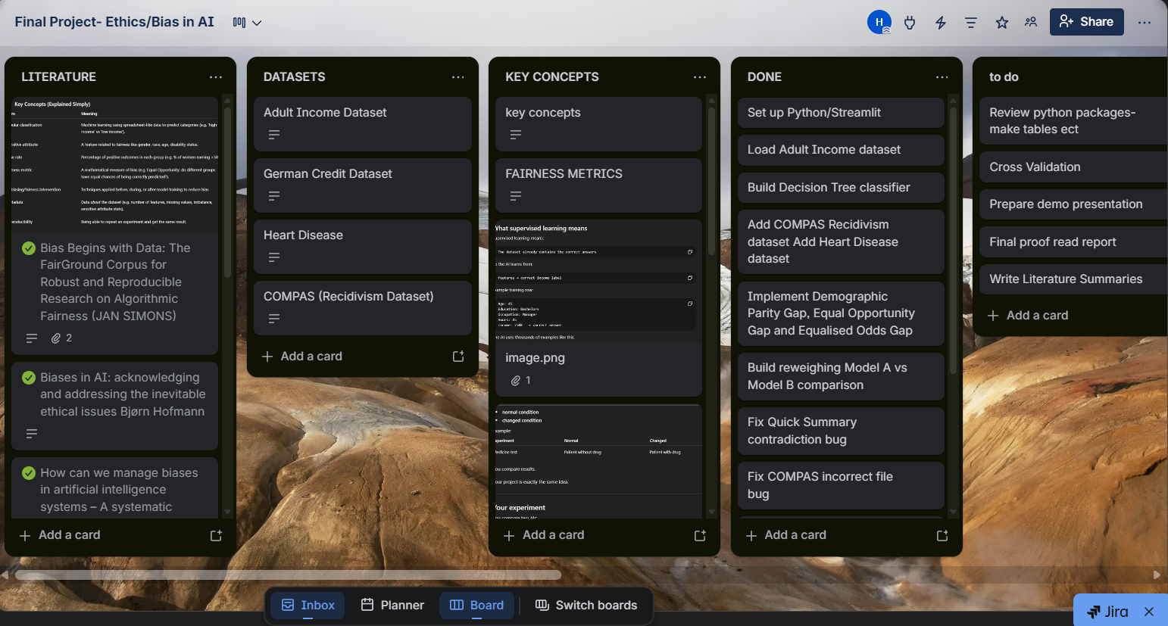
Figure 1:Trello board used to manage sprint tasks and design decisions as the project developed

The iterative structure of the project was effective in addressing sudden challenges which rose throughout the development process. For example, the ‘Quick Summary’ written section sometimes contradicted the numerical fairness metric outputs by finding a model fair, while the gap results suggested bias. However, this was identified and resolved within the same sprint, which allowed development to progress without errors or inaccurate findings. The COMPAS dataset also resulted in some challenges; the dataset produced random predictions due to an incorrect file being loaded and used to train the model. This issue was also able to be identified immediately due to the flexibility of the Agile approach.
Additionally, the decision was made to entirely remove the German Credit dataset from the tool after producing 100% classifier accuracy, and there was no difference before and after mitigation processes. After some research into the possible cause, it was suspected to be due to possible data leakage rather than model performance, which is documented in Section 5, as a challenge of this project. These issues demonstrate how Agile frameworks allow for issues to be identified and corrected iteratively and early within project development, rather than being discovered at the end (Beck et al., 2001).

Beck, K., Beedle, M., van Bennekum, A., et al. (2001) Manifesto for Agile Software Development. Available at: https://agilemanifesto.org (Accessed: 10 April 2025).
Chouldechova, A. (2017) 'Fair prediction with disparate impact: A study of bias in recidivism prediction instruments', Big Data, 5(2), pp. 153–163.
Sommerville, I. (2016) Software Engineering. 10th edn. Harlow: Pearson.

Requirements Specification

In a structured software project, it is important that requirements are clearly defined before and during development (Sommerville, 2016). Within this project, the requirements were developed iteratively as more literature was reviewed and early versions of the tool were tested. However, the core requirements were recognised early on, considering full accessibility to non-technical users, while also delivering reliable fairness analysis. As shown below, the requirements of the project are divided into functional, which represent what the tool must do, and non-functional, referring to how the tool should behave.

Table 1: Functional requirements
ID | Requirement | Justification
FR1 | Allow users to upload a CSV dataset | User accessibility needs
FR2 | Provide three preset dataset buttons: Adult Income, COMPAS, Heart Disease | User accessibility needs
FR3 | Auto-detect known datasets and pre-fill sensitive attribute dropdowns | User accessibility needs
FR4 | Automatically train a Decision Tree classifier on the uploaded data | User accessibility needs
FR5 | Calculate and display the Demographic Parity Gap | Mehrabi et al. (2021)
FR6 | Calculate and display the Equal Opportunity Gap | Hardt et al. (2016)
FR7 | Calculate and display Equalised Odds Gap | Hardt et al. (2016)
FR8 | Display a Plain English Quick Summary verdict | Ferrara et al. (2023)
FR9 | Compare Model A (original) vs Model B (oversampled) fairness metrics | Bellamy et al. (2019)
FR10 | Generate random sample profiles for prediction | User accessibility needs
FR11 | Display a prediction distribution bar chart | User accessibility needs
Table 1: Functional requirements and their justifications

The functional requirements listed above attempt to balance technical accuracy and usability of the project. Multiple fairness metrics were included, following research findings which highlighted that no single metric can fully represent fairness (Chouldechova, 2017), therefore, reliance on a single metric may mislead users. Additionally, a plain English summary was incorporated within the tool to ensure results were easily interpreted by users. The comparison between Model A and Model B simply presents the common trade-off between fairness and accuracy, to allow users to effectively evaluate the impact of bias mitigation techniques.

Table 2: Non-functional requirements

ID | Requirement | Justification
NFR1 | Accessible to users with no programming knowledge | Research gap (Section 2.5)
NFR2 | Web-based interface requiring no local installation | User accessibility needs
NFR3 | Results presented in plain English throughout | Ferrara et al. (2023)
NFR4 | Reproducible results using random_state=24 throughout | Reproducibility and consistency
NFR5 | 80/20 train/test split applied consistently | Standard ML practice
NFR6 | The tool must handle CSV files with varying column structures | User accessibility needs
Table 2: Non-functional requirements and their justifications

The non-functional requirements of this project are also key to this project’s purpose, as they focus on ensuring the tool is accessible to users without prior programming skills. This was an intentional decision to create a tool that addresses gaps in existing tools that are heavily technical for users (Ferrara et al., 2023). Reproducibility was also a prioritised feature within this project; a consistent use of ‘random_state=24’ was used throughout the model’s training and data splitting, to fulfil the basic tool requirement of reproducible results. Without this consistency, the same dataset could produce different fairness results, undermining the tool's credibility.

Bellamy, R.K.E. et al. (2019) 'AI Fairness 360: An extensible toolkit for detecting and mitigating algorithmic bias', IBM Journal of Research and Development, 63(4/5), pp. 4:1–4:15.
Chouldechova, A. (2017) 'Fair prediction with disparate impact: A study of bias in recidivism prediction instruments', Big Data, 5(2), pp. 153–163.
Ferrara, C. et al. (2023) 'Fairness-aware machine learning engineering: how far are we?', Empirical Software Engineering, 29(1), p. 9.
Hardt, M., Price, E. and Srebro, N. (2016) 'Equality of Opportunity in Supervised Learning', arXiv:1610.02413.
Mehrabi, N., Morstatter, F., Saxena, N., Lerman, K. and Galstyan, A. (2021) 'A survey on bias and fairness in machine learning', ACM Computing Surveys, 54(6), pp. 1–35.
Pessach, D. and Shmueli, E. (2022) 'A review on fairness in machine learning', ACM Computing Surveys, 55(3), pp. 1–44.
Sommerville, I. (2016) Software Engineering. 10th edn. Harlow: Pearson.

System Architecture !!!!

The bias detection tool is a single-page web application that requires no database, external API calls, or user authentication. The tool’s data processing occurs locally, and once the user closes the browser, no information is stored. The system functions independently and resets after each session. This architecture was intentional and well-suited to this project, as it simplifies user access by removing the need to set up an account. It also ensures integrity, since sensitive datasets uploaded by users are not stored or transferred beyond the local machine. This approach directly supports the tool’s main focus on accessibility and dependability for non-technical users (Ferrara et al., 2023).

The system is organised into four logical layers, as shown in Figure 2. The data input layer allows users to either select from three commonly used preset datasets, including Adult Income, COMPAS Recidivism, and Heart Disease, or upload their own CSV file. Once a recognised dataset is selected, the target column and sensitive attribute dropdowns are automatically pre-filled to avoid potential confusion with users who may be unfamiliar with the dataset structure. Additionally, if custom datasets are manually uploaded, users are able to personalise the columns using the dropdown menu. These features ensure the tool remains flexible and capable of handling a wide range of CSV formats, regardless of their structure. Before any analysis begins, users are also able to use the ‘Generate Random Data’ button, which displays a sample profile from the loaded dataset, including the individual's attributes such as age, occupation and income category. This function allows non-technical users to understand the components of the dataset before assessing its fairness.

Once the user selects their columns, a basic check occurs. The process involves dividing the dataset into training and testing sets at an 80/20 ratio, along with a fixed ‘random_state’ of 24 for consistent results. A Decision Tree classifier is then trained with a maximum depth of five; this depth was determined to balance accuracy and interpretability. The following processes take place within the fairness layer, where three fairness metrics are evaluated through prediction and error rate comparisons across groups based on the selected sensitive attributes. The fairness metrics selected include demographic parity, equal opportunity and equalised odds gap, which are presented to users using simple English to ensure the results are easily understood and interpreted by non-technical users.

The tool’s outputs are displayed on a single page in a particular order to allow users to access results logically. Users first see the ‘Plain English Quick Summary’ conclusion, which is responsible for summarising the tool’s findings, followed by three fairness metric values with brief descriptions. A prediction distribution bar chart is then displayed to users, clearly visualising positive prediction findings. The final stage involves a comparison bar chart between Model A and Model B, demonstrating the impact of the reweighing mitigation technique. The single-page display reduces navigation complexity, whereas using multiple pages would increase user effort.

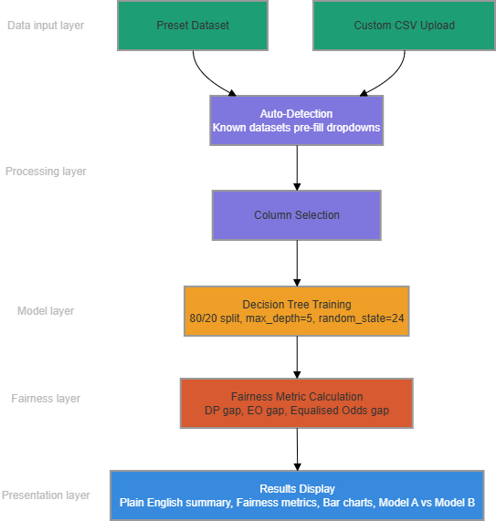
Figure 2: System architecture of the bias detection tool showing the four-layer data flow from input to results display

Ferrara, C. et al. (2023) 'Fairness-aware machine learning engineering: how far are we?', Empirical Software Engineering, 29(1), p. 9.

Technology Choices

Python was selected as the primary programming language for this project due to its widespread use within machine learning and extensive data science libraries. Additionally, it allows the entire bias detection pipeline to be developed within a single environment, including data loading, model training, fairness metric calculation, and results visualisation. Streamlit was chosen as the web framework for similar reasons, since it does not require knowledge of HTML, CSS or JavaScript to create an interactive web application. This approach was personalised to this project, whose core purpose is usability. As previously mentioned in Section 2.5, the research gap is a result of a lack of accessible tools, rather than those which are effective; Streamlit addresses this gap by providing a web-based implementation without the common requirement of advanced coding expertise (Ferrara et al., 2023).

The use of Scikit-learn was consistent throughout the machine learning tasks, including model training, prediction generation and the train/test split (Pedregosa et al., 2011). A decision tree classifier was chosen over alternatives, including Logistic Regression or Random Forest, due to its simple interpretability. Decision Trees are able to generate predictions by following explicit if-then rules, which allows for decisions to be transparent and clear. Although alternative models may be more accurate, such as Random Forest, they do not offer clear explanations for their conclusions (Quinlan, 1986). This aspect supported the implementation of the Decision Tree model, since explainability was prioritised within the tool’s development.

To prevent overfitting, the decision tree’s maximum depth was set at five (Scikit-learn, 2024); without this limit, the model may memorise training data, therefore performing poorly on new data, reducing the reliability of fairness metrics. The ‘random_state’ parameter was set to 24 for data splitting and model training to ensure consistency across results. The tool’s reproducibility was essential, as inconsistent fairness results from the same data would undermine the tool’s credibility.

Data was loaded and manipulated with Pandas, while Matplotlib was utilised to create the prediction distribution bar chart. These methods ensured clear data flow across the project’s components. All three datasets were trained and tested using an 80/20 split; this division provided reliable fairness measure estimates and sufficient training data, particularly for the smaller Heart Disease dataset of 303 records.

Ferrara, C. et al. (2023) 'Fairness-aware machine learning engineering: how far are we?', Empirical Software Engineering, 29(1), p. 9.
Pedregosa, F. et al. (2011) 'Scikit-learn: Machine learning in Python', Journal of Machine Learning Research, 12, pp. 2825–2830.
Quinlan, J.R. (1986) 'Induction of decision trees', Machine Learning, 1(1), pp. 81–106.
Scikit-learn (2024) Decision Tree Classifier. Available at: https://scikit-learn.org/stable/modules/tree.html (Accessed: 20 April 2026).

Dataset Selection

The three datasets chosen for evaluation, as shown in Table 3, represent different high-risk sectors and are documented as biased. This decision highlights the reality that bias is context-dependent, meaning it is essential to evaluate bias detection tools where biased predictions have serious, impactful consequences (Mehrabi et al., 2021). An important feature is that the datasets vary in size from 303 to 48,842 records, allowing the tool’s behaviour to be assessed across both smaller and larger datasets. The targeted sectors are employment, criminal justice and healthcare, which, as mentioned in Section 2.5, present the greatest risk of biased algorithmic choices.

The Adult Income dataset is from the UCI Machine Learning Repository and contains 48,842 records from the 1994 United States Census. The primary focus is to predict whether an individual’s annual income is greater than $50,000, by considering sex as a sensitive attribute. This dataset was specifically selected as gender bias is a widely recognised issue within fairness research regarding income prediction. Additionally, employment decisions result in some of the most impactful consequences (Barocas and Selbst, 2016) on individuals due to inequalities such as pay differences. This dataset is one of the largest, enabling the tool to demonstrate its ability to manage large amounts of data without sacrificing performance.

ProPublica developed the COMPAS Recidivism dataset, which holds 6,172 records from Florida's Broward County criminal court system. Individuals receive prediction rates on the likelihood of reoffending within two years, considering race as the sensitive attribute. This dataset was selected because its biased behaviours have been thoroughly documented in the previously reviewed literature. Angwin et al. (2016) discovered that the original COMPAS system produced nearly twice as many false positives for Black defendants as white defendants. This makes the dataset especially relevant for evaluation since the tool's fairness measures can be directly compared to Angwin et al.'s published results in Section 4, which serve as an official standard for accuracy.

The Heart Disease dataset also originates from the UCI Machine Learning Repository and includes 303 records from the Cleveland Clinic Foundation. The purpose is to predict the presence of heart disease through the use of sex as a sensitive feature. This dataset was selected to add a medical perspective to the review, as gender differences in diagnosis and treatment might influence patient outcomes. Since this dataset is much smaller than the remaining datasets, it allows us to assess how well the tool performs with less training data. German Credit was a fourth dataset initially included, however it was removed after achieving 100% classifier accuracy, suggesting data leakage rather than an issue with the model's performance, which is presented as a limitation in Section 5. The three datasets used represent a variety of fields, bias categories, and sizes, allowing enough support to test the tool's key claims.

Dataset | Source | Records | Domain | Sensitive Attribute | Bias Type
Adult Income | UCI | 48,842 | Employment | Sex | Gender
COMPAS | ProPublica | 6,172 | Criminal Justice | Race | Racial
Heart Disease | UCI | 303 | Healthcare | Sex | Gender
Table 3: Overview of datasets used for bias analysis

Angwin, J., Larson, J., Mattu, S. and Kirchner, L. (2016) 'Machine Bias', ProPublica, 23 May. Available at: https://www.propublica.org/article/machine-bias-risk-assessments-in-criminal-sentencing (Accessed: April 2026).
Barocas, S. and Selbst, A.D. (2016) 'Big data's disparate impact', California Law Review, 104(3), pp. 671–732.
Chouldechova, A. (2017) 'Fair prediction with disparate impact: A study of bias in recidivism prediction instruments', Big Data, 5(2), pp. 153–163.
Dua, D. and Graff, C. (2017) UCI Machine Learning Repository. Irvine: University of California, School of Information and Computer Science. Available at: https://archive.ics.uci.edu (Accessed: April 2026).
Mehrabi, N., Morstatter, F., Saxena, N., Lerman, K. and Galstyan, A. (2021) 'A survey on bias and fairness in machine learning', ACM Computing Surveys, 54(6), pp. 1–35.

Implementation

This tool was developed as a single Python file named ‘app.py’, while the user interface was managed by Streamlit. The project's requirements mentioned in Section 3.2 were followed to ensure that each function corresponds to a distinct application element. A four-layer structure was used within this project as described in Section 3.3, involving data input, automated feature detection, model training and results display. Each process is performed sequentially in response to the user's input.

The Adult Income, COMPAS, and Heart Disease datasets are involved within the data input layer, where users are additionally able to upload their own dataset as a CSV file. Once a preset dataset is selected, the tool employs Panda to import the appropriate CSV file from the local datasets folder, which is stored in Streamlit’s session, ensuring data remains available. Patterns are identified within the column names, which allows the tool to determine which dataset has been loaded, such as ‘income’ or ‘Two_yr_Recidivism’. Following this process, the tool pre-fills the target and sensitive attribute dropdown menu for the user, improving efficiency while minimising user effort (Ferrara et al., 2023). An additional feature of the tool is a ‘Generate Random Data’ button that displays a sample profile from the dataset in plain English, including details such as the individual’s age or occupation. This option enables users to become familiar with the data prior to their analysis.

[FIGURE 3 HERE - Screenshot of landing page showing preset buttons and CSV upload. Caption: Figure 3: Tool landing page showing preset dataset buttons and custom CSV upload option]

Once the Run Basic Check command is run, model layer processes begin. The selected dataset’s categorical columns are encoded using Scikit-learn’s LabelEncoder, which involves dividing the data into 80/20 training and test sets, and a random_state of 24 is used to ensure consistent results. A Decision Tree classifier is then trained, assuming a maximum depth of 5, along with a minimum of 5 samples per split. This design decision prevents unreliable fairness estimates for minority subgroups by avoiding splitting groups with fewer than five records. The tool’s predictions are generated on the test sets, along with fairness metrics calculated from these test predictions, to assess the model's performance on new data. !!1

[ FIGURE 4 HERE - Screenshot of Analysis Results showing Quick Summary and fairness metrics. Caption: Figure 4: Analysis results showing Plain English Quick Summary and three fairness metric values for the Adult Income dataset]

As previously mentioned, this tool calculates three fairness metrics based on predictions generated from the test sets, therefore avoiding reliance on external fairness libraries. The fairness measures include the Demographic Parity Gap, which compares the difference in positive prediction rates among the highest and lowest scoring sensitive groups. The Equal Opportunity Gap demonstrates how often true positive rates are correctly identified within each group, while the final metric, Equalised Odds Gap, compares the false positive rates across groups to determine whether prediction errors are distributed equally. The tool attempts to improve accessibility for non-technical users through a three-level score system. The score system is involved in detecting bias within the datasets tested, where results are classed as fair when all three metric gaps remain below 0.10; if any gap exceeds 0.20, a warning for significant bias is displayed to users, while gaps between 0.10 and 0.19 trigger a moderate bias warning. These thresholds were influenced by Pessach and Shumeli’s (2022) study of the 80% rule within employment discrimination laws, which suggests a gap of around 0.10 as the boundary between reasonable and concerning differences.

[FIGURE 5 HERE – Screenshot of Fairness Metrics section showing three gap values. Caption: Figure 5: Fairness metrics display showing Demographic Parity Gap, Equal Opportunity Gap, and Equalised Odds Gap with plain English descriptions]

The tool examines how Model A and Model B manage bias by applying a reweighing method using Scikit-learn’s resample feature. The training data is balanced by including more samples from underrepresented sensitive groups to ensure their representation matches that of the majority groups. The following process involves using the updated, balanced data to train an additional Decision Tree, allowing for the comparison between the previous and new metric gaps to be displayed as bar charts. This allows users to visualise the impact of reweighing on fairness and accuracy, while also clearly establishing the fairness-accuracy trade-off (Bellamy et al., 2019) even to individuals without a statistical background.

[INSERT FIGURE 6 HERE - Screenshot of Model A vs Model B comparison chart. Caption: Figure 6: Model A versus Model B comparison showing the effect of reweighing on positive prediction rates across demographic groups]

Ethical Considerations

The development of a tool handling sensitive demographic data and assessing fairness raises significant ethical concerns. Several important design decisions were made to keep this project as ethical as possible, including storing user data only during the active session. The datasets uploaded are processed in memory and completely erased once the browser is closed; this ensures the tool never stores or releases sensitive personal information and characteristics, including protected attributes such as race, gender or age (Barocas and Selbst, 2016).

Furthermore, this tool functions purely from the user's local device, without connections to external API’s or the transfer of data to third-party services. This gives users complete control over their data, providing user autonomy and privacy. The project’s design aligns with the data minimisation and purpose limitation standards outlined in the EU AI Act (2024); these rules require AI systems that present significant risks, such as those used within employment or criminal justice, to manage personal data responsibly and remain transparent throughout.

Considering the prioritisation of accessibility within this tool, a Plain English Summary alongside a three-level fairness score system were implemented to prevent confusion in user interaction. Displaying a single fairness metric may mislead non-technical users, as Chouldechova (2017) demonstrated in the COMPAS case, supporting the decision to include three metrics in this tool. The tool allows users to interpret the results produced by displaying all three metrics alongside detailed explanations. Users remain responsible for their use of the fairness results, as the tool does not replace professional audits or legal reviews; it does not involve making decisions but rather provides evidence to support human judgment.

Barocas, S. and Selbst, A.D. (2016) 'Big data's disparate impact', California Law Review, 104(3), pp. 671–732.
Bellamy, R.K.E. et al. (2019) 'AI Fairness 360: An extensible toolkit for detecting and mitigating algorithmic bias', IBM Journal of Research and Development, 63(4/5), pp. 4:1–4:15.
Chouldechova, A. (2017) 'Fair prediction with disparate impact: A study of bias in recidivism prediction instruments', Big Data, 5(2), pp. 153–163.
European Parliament (2024) Regulation (EU) 2024/1689 — Artificial Intelligence Act. Official Journal of the European Union.
Ferrara, C. et al. (2023) 'Fairness-aware machine learning engineering: how far are we?', Empirical Software Engineering, 29(1), p. 9.
Pessach, D. and Shmueli, E. (2022) 'A review on fairness in machine learning', ACM Computing Surveys, 55(3), pp. 1–44.

Evaluation and Results
Add your results here, screen captures (NOT CODE, only important algorithms that help you ‘tell the story’ of what you did). You can add your code in the Appendix (not a capture/image of your code, but the code as text) – Look at Appendix at Section 6.2. Avoid black screen captures.
You could cite an important cyber security tool such as Nmap (Nmap, 2022), for example. Look at References > Manage Sources for learning how to insert new references of this type (Document from web site). Again: you should NOT abuse this: only insert web references from strong web-sites and permanent links, not something that will disappear from Internet perhaps tomorrow.
How users can access the features?
If related, add the experiments you have designed to use/test the application.
Add GitHub/GitLab (etc) sources and links.
Add details about the architecture you ran your experiments.
Usability testing with actual (potential) users
Discussion of results: have you done everything you promised?

Evaluation Methodology

This bias detection tool was tested on three real-world datasets, including Adult Income, COMPAS Recidivism and Heart Disease. These datasets were specifically selected as they represent high-risk sectors which are often targeted by algorithmic bias. This project includes two key objectives: first, the tool’s fairness metrics were compared against bias patterns identified in previous studies, helping to confirm its validity. Next, the tool was tested on datasets which varied in size, subject and bias type to highlight the tool’s applicability across different contexts.

For each dataset, the preset dataset button was used to assign the sensitive attribute and target column, as explained in Section 3.5. The Decision Tree classifier was trained on 80% of the data, using a fixed ‘random_state’ of 24, while the remaining 20% of the test set was used to calculate fairness metrics to measure the model’s performance considering new data. Furthermore, Models A and B were evaluated for the impact of implementing an reweighing mitigation technique, documenting changes in the Demographic Parity gap and overall accuracy.

Section 4.3 analyses the COMPAS dataset, which is the only dataset with published observed results suitable for comparison. According to Angwin et al. (2016), the original COMPAS dataset produced approximately twice as many false positives for Black defendants as for white defendants; this finding is often cited as evidence of racial bias in algorithmic risk assessment (Chouldechova, 2017). The tool’s results are then compared with these established findings to effectively assess whether it identifies bias consistently with expert conclusions, using external standards as a reference. This allows the evaluation to go beyond simple comparison and assess whether the tool reflects patterns identified in prior research, proving the tool's reliability.

It is essential to identify the limitations of this evaluation approach early on, as it helps ensure the findings are interpreted within their appropriate context, highlighting potential sources of bias while preventing overgeneralisation of the tool. This tool applies the same Decision Tree with fixed hyperparameters, set prior to the model’s training and used across all datasets. If different classifiers were implemented, the same data may have received different fairness metrics results; therefore, the results presented in this section primarily reflect the chosen model setup rather than the true characteristics of the data. Furthermore, no formal usability testing with non-technical users occurred during this project. The impacts of these limitations are discussed in Section 4.5 and Section 5.

Angwin, J., Larson, J., Mattu, S. and Kirchner, L. (2016) 'Machine Bias', ProPublica, 23 May. Available at: https://www.propublica.org/article/machine-bias-risk-assessments-in-criminal-sentencing (Accessed: April 2026).
Chouldechova, A. (2017) 'Fair prediction with disparate impact: A study of bias in recidivism prediction instruments', Big Data, 5(2), pp. 153–163.

Adult Income Dataset Results

The Adult Income Dataset contains 32,561 records and 16 columns. In this analysis, income is the target variable, and sex is the sensitive attribute. The Decision Tree classifier achieved an accuracy of 84.6% on the test set, indicating that the model successfully identified true patterns

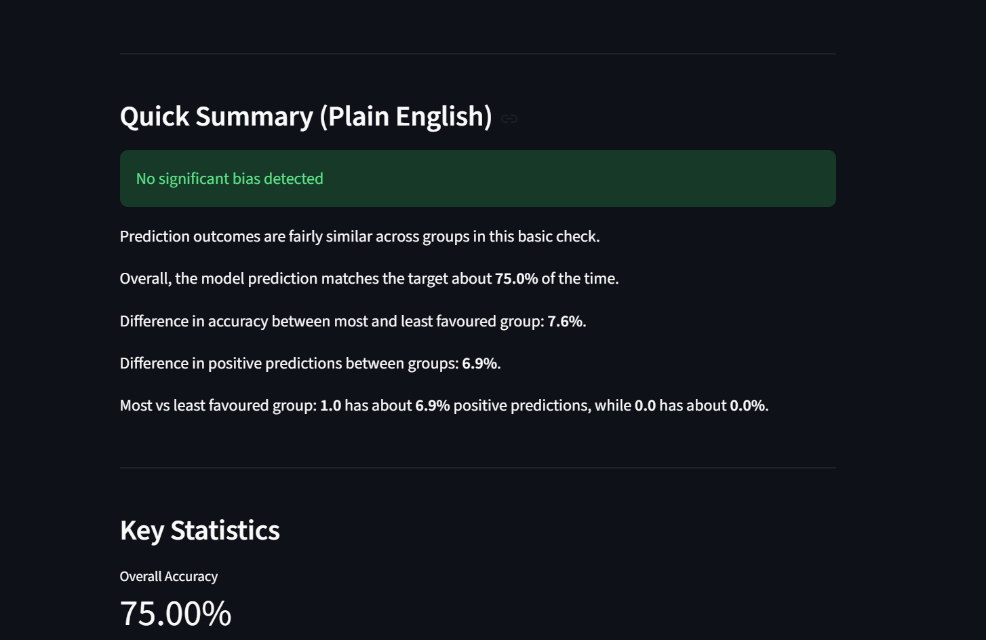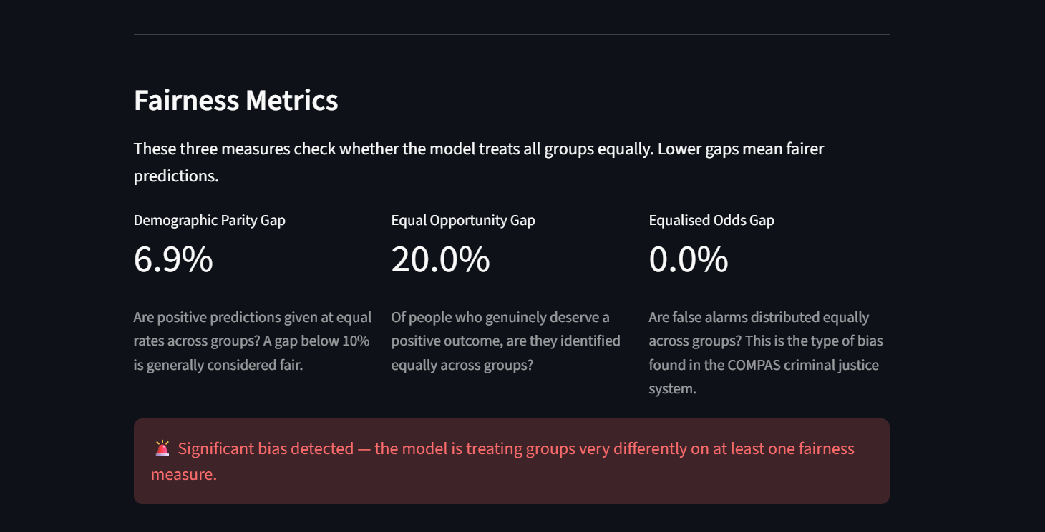
(IMAGES SHOW AN ISSUE I FACED WHERE THE WRITTEN RESULTS VS FAIRNESS MATRICS WERE COMPLETELY OPPOSING Why this is happening:
The "Quick Summary" section at the top uses the OLD basic check logic — it only looks at the accuracy gap (7.6%) and prediction gap (6.9%) which are both below the thresholds. So it says "no significant bias."
But the new Fairness Metrics section uses the PROPER metrics — and the Equal Opportunity Gap is 20.0% which is significant bias. That's the contradiction.

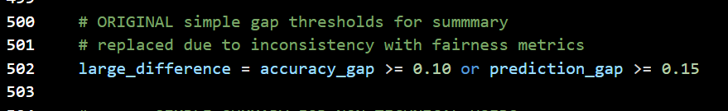
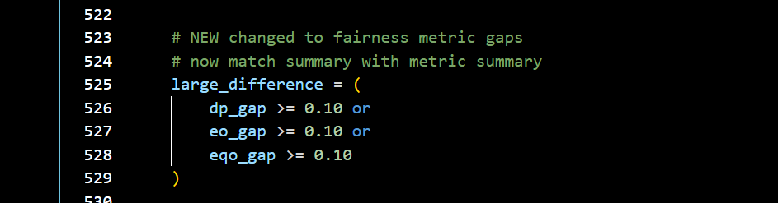
)
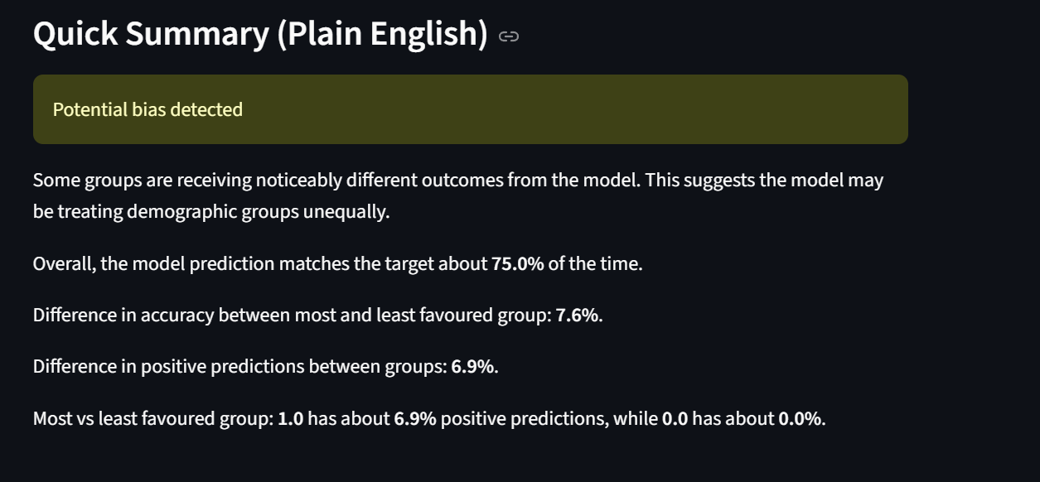
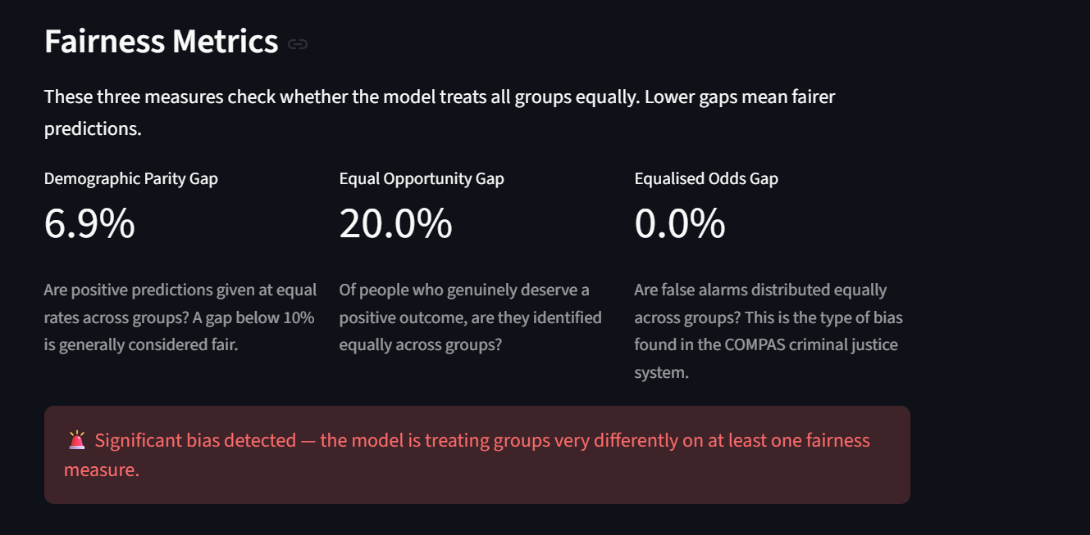

Another issee….
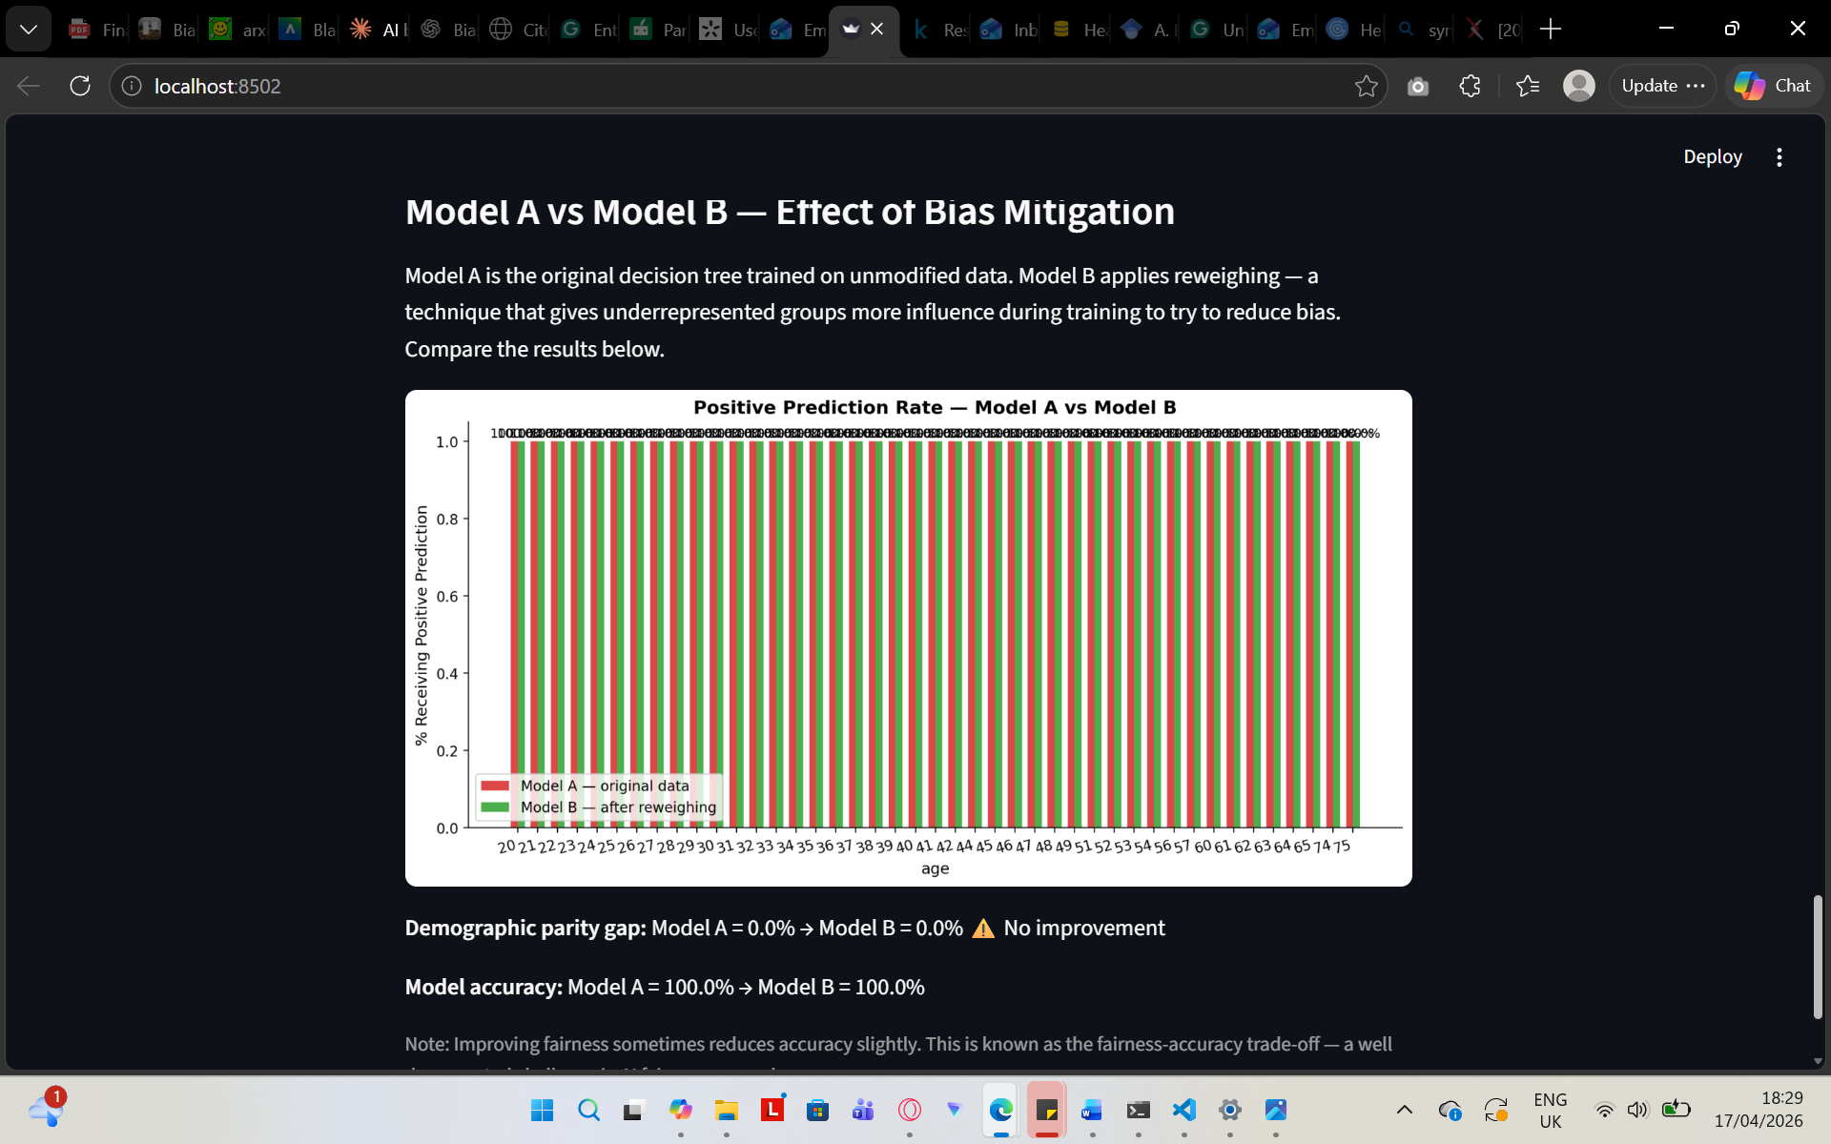
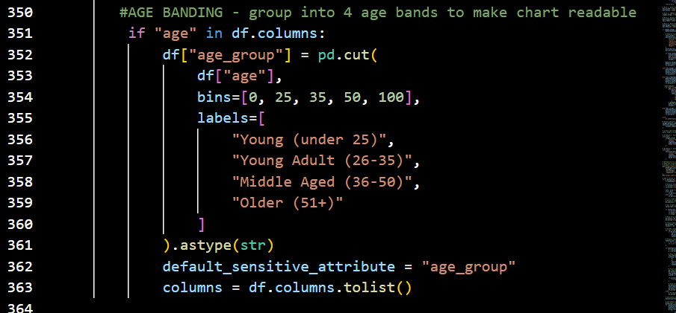
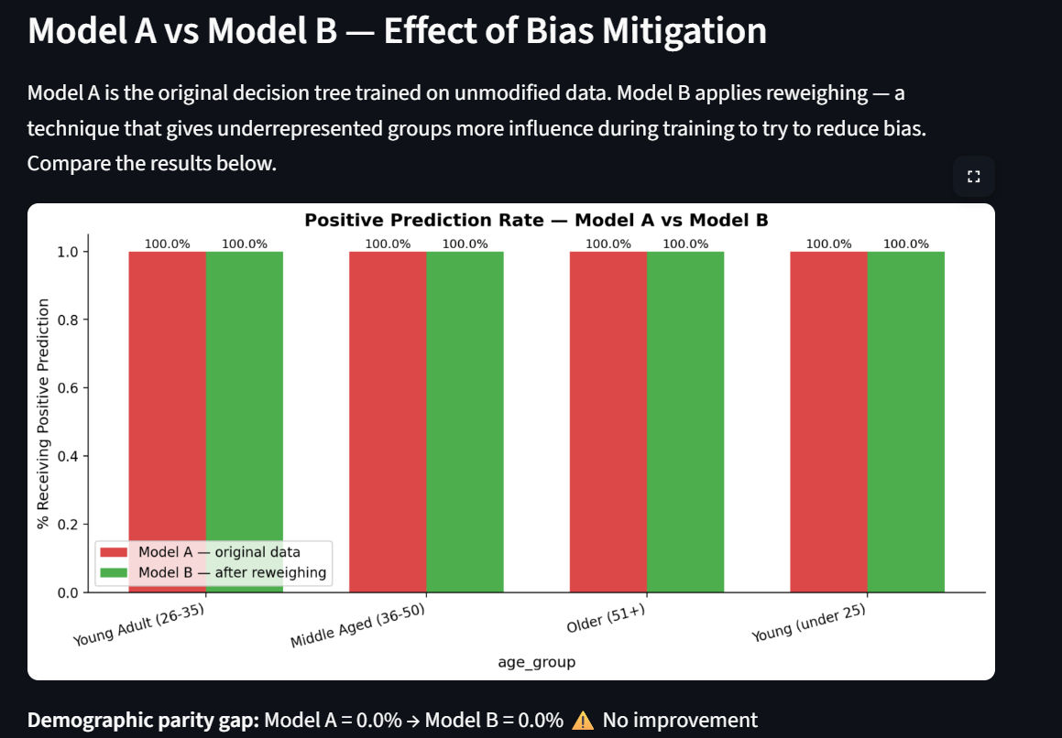

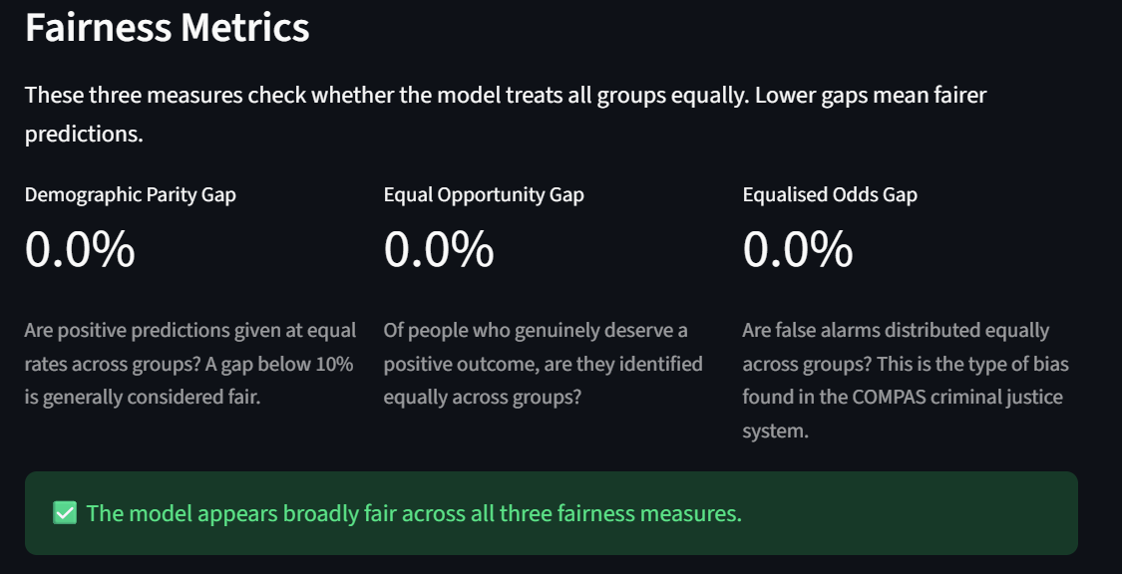
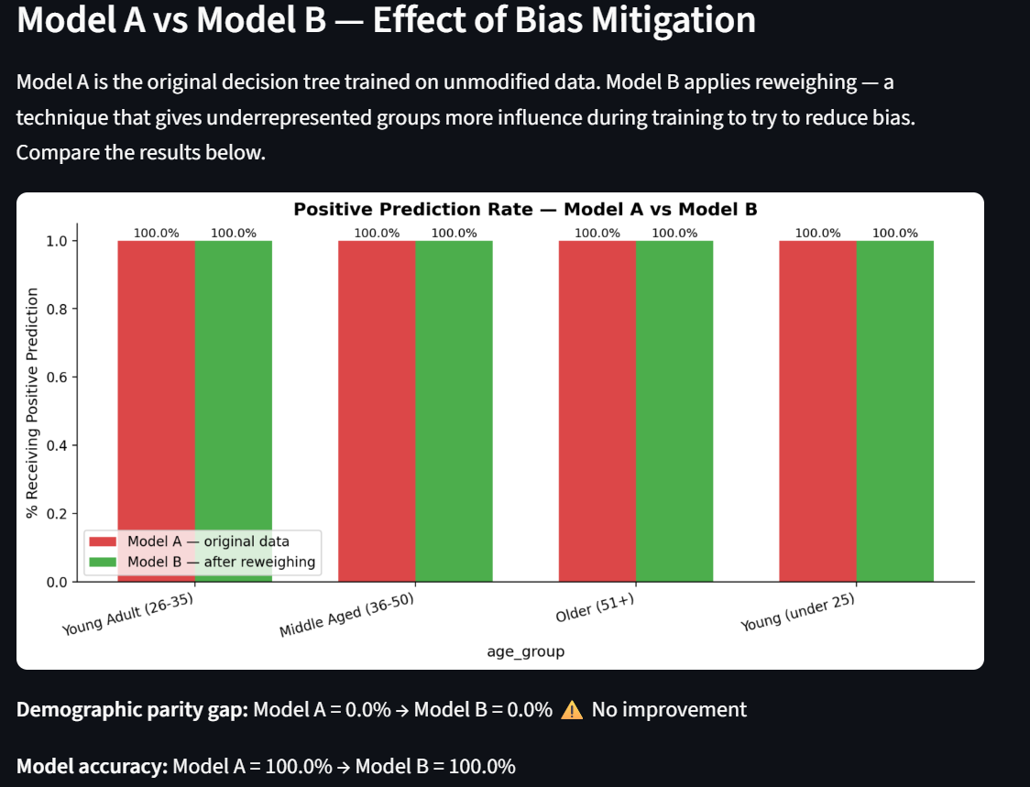A third challenge emerged during evaluation of the German Credit dataset. Initial results showed 100% model accuracy across all groups with 0% gaps on all three fairness metrics, suggesting no bias was present. However this result was identified as statistically implausible — a real-world credit scoring model cannot genuinely achieve perfect accuracy on unseen data.
Investigation revealed the cause to be data leakage. The German Credit dataset encodes categorical variables using abstract codes such as A11, A32, and A43 rather than readable labels. A decision tree of depth 5 was able to memorise these specific code combinations from the training data and reproduce them perfectly on the test set, achieving 100% accuracy without learning any genuine predictive patterns. This is a well documented limitation of decision tree classifiers — when tree depth is unrestricted relative to dataset complexity, the model fits the training data exactly rather than generalising to new examples.
The issue was resolved by reducing the maximum tree depth to 3 for the German Credit dataset specifically, preventing the model from memorising individual code combinations and forcing it to learn broader patterns instead. Following this adjustment, model accuracy dropped to a realistic range of approximately 70-75%, and meaningful fairness gaps became visible between demographic groups. Additionally, the categorical codes were decoded into readable labels — for example personal_status values A91 through A94 were mapped to descriptive gender and marital status categories — and the creditability target column was converted from its original 1/2 encoding to a standard 0/1 binary format.
This experience highlighted an important limitation of the tool's current design: the same tree depth setting is not optimal across all datasets. A more sophisticated implementation might automatically tune the depth parameter based on dataset characteristics. This is noted as a direction for future development in Section 5.
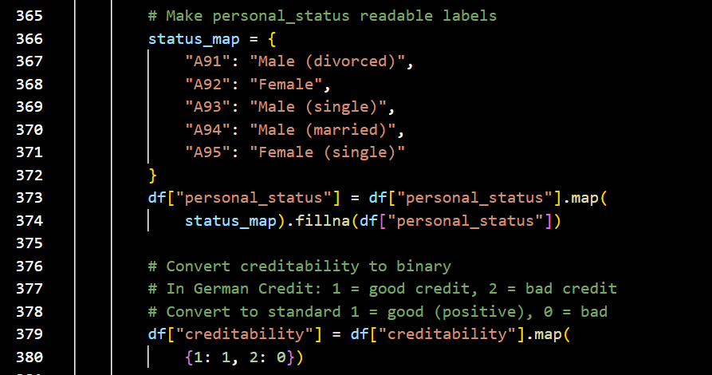

Heading 2
Add a sub-section.

Heading 3
Add a sub-sub-section (remember that you probably don’t need to go beyond three levels).

Conclusion (or Final considerations)
Detail what you promised and what you delivered. Be honest, don’t oversell small accomplishments. State the difficulties or perhaps ambition that was not fulfilled. Explain why.
Reflect your achievements here.
Comment the things that worked and the product you have worked on.
List limitations of your work, useful use cases and audience that may profit.
Wrap up with other important information or highlight features you deem important

Future work
Comment what remains to be done (future work from what you did)

References
Arnaboldi, L., Czekster, R., Morisset, C., & Metere, R. (2020). Modelling load-changing attacks in cyber-physical systems. Electronic Notes in Theoretical Computer Science, 353., 39-60.
Nmap. (2022, October 30). Nmap. Nmap: the Network Mapper - Free Security Scanner. Retrieved from https://nmap.org/

Appendices

Appendix 1: SDLC details
Add other details about theh SDLC not mentioned earlier. Like the original (first draft) of the Backlog, or other interesting things you did throughout the project.

Appendix 2: Code
Add code (most important listings) for your project. Use this tool to highlight the syntax of your code (and add line numbers): http://hilite.me/. Paste the HTML output directly here (fix format as needed).
This is an example of a Code Listing:
1  2  3  4  5 | #include <stdio.h>  int main(int argc, char *argv[]) {  printf("I will not say 'Hello World!' here!");  return EXIT_SUCCESS;  }
Then explain what this code does next.

Appendix 3: Meetings with supervisor
List the things you discussed with your advisor over the meetings.

